SELF ASSESSMENT

Criteria:

1. Conceptual coverage: 40pts

Included:

* various data types, variable and operators for calculate dices total and cases
* use bult-in function: fprintf, input, disp, sprint,strcmp, randi, sum, subplot, length, imshow, title, axis, text….
* Use vectors(2d array) for store odds and bet, utilize index in 2d array to navigate cases.
* Use iteration loop: for loop

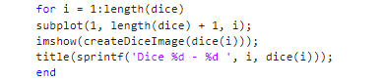

While loop: for the whole game to start game, prevent wrong inputs and so on..

* Use nested vector on whole project
* This game is condition-based game
* Use function to call game

1. Value add: 20pts

* Over 460 line of codes, use 8 line of code for partly displaying with high customization

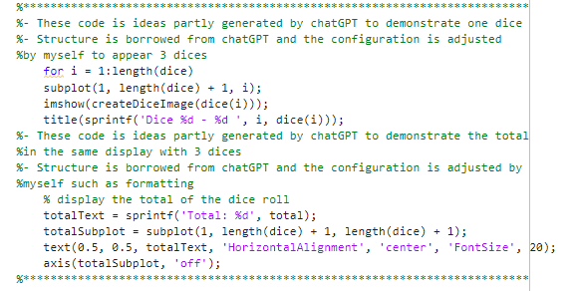

* Learn more buit-in functions: strcmp, subplot, title…
* Learn how to create dice display
* Learn how to utilize function to create main menu for interaction with users
* Develop and enhance experience by prevent invalid input, develop more way for user to play, game modes and navigation in menu
* Display dices for user for interactive and informative game experience
* …..

1. Incremental development: 15pts

* Having developed game with many stages and functionality test of each parts of game, represented in detail in **roadmap.txt** and in-game( *File included in submission)*

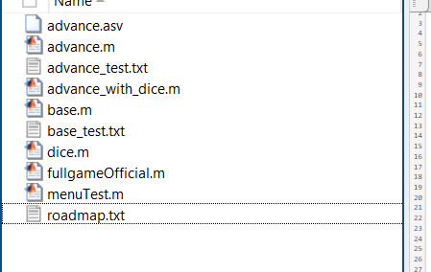

1. Testing Strategy: 11.25 pts

* create dedicated test files for 2 major components of the game ( base and advance)

1. Comments and styles: 10pts

* Provided concise and detail comment(in **fullgame**) and apply naming convention thoroughly